USER INTERFACE DESIGN EXPERIMENT – 4

Name: DURAIMADHAN M M ROLL NO:240701131

Create a prototype with familiar and unfamiliar navigation elements. Evaluate ease of use with different user groups using proto.io

HOSPITAL APPOINTMENT APP :

SCREEN 1: SIGN-IN PAGE
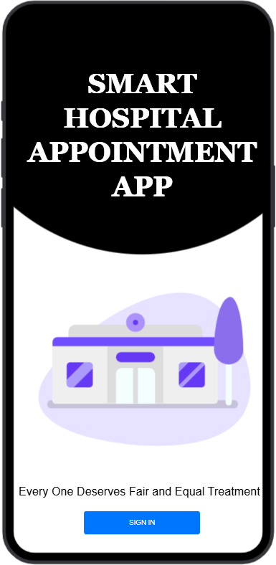

SCREEN 2: HOME DASHBOARD
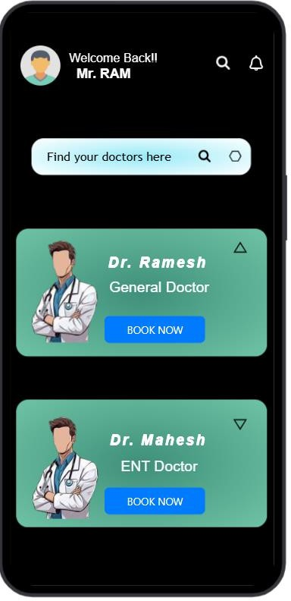
Purpose: Allows user to search and choose doctor.

Familiar Icons
- Search Icon
  - Commonly used to find doctors.
  - Clicking allows typing doctor name.

Notification Bell
  - Standard icon for alerts/reminders.

Profile Avatar
  - Shows logged-in user.

Unfamiliar Icons

- Triangle beside doctor card
  - Custom indicator showing doctor availability / expansion.
  - Not universally recognised.

Hexagon in search bar
  - Not known initially for what it is used for.Would have been about filter.
  - Users must learn meaning.

Screen 3: Doctor Details Page:



Purpose: Shows doctor info + booking option.

Familiar Icons
- Back Arrow (←)
  - Returns to previous page.

Star Rating
  - Shows doctor rating.

Unfamiliar Icons
- Upward Symbol near doctor profile
  - Used as privacy indicator.
  - Meaning not obvious without explanation.

Red dot near experience
  - Custom visual meaning low experience.
  - Not standard UI symbol.

Screen 4 : Slot Selection Page with Preview:
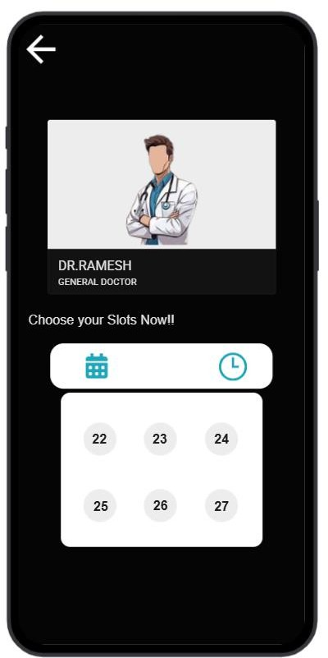
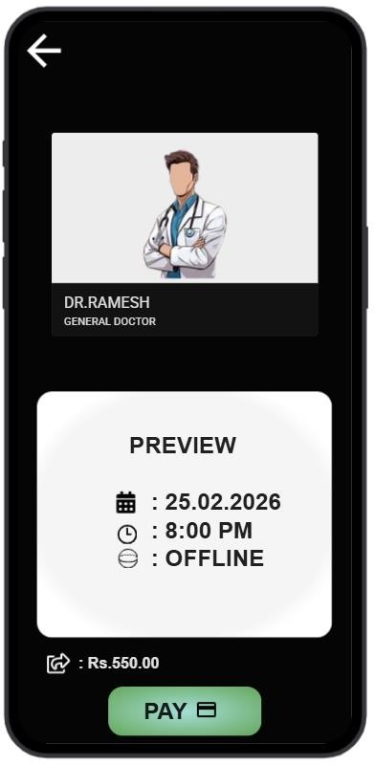
Purpose: User chooses appointment date and time.

Familiar Icons
- Calendar icon
  - Opens date selector.

Clock icon

  - Opens time selector.

Unfamiliar Icons
- Geosphere icon in preview
  - Meaning cannot be arriven completely.
  - It might be about the mode as the icon looks unfamiliar to users conclusion is bit difficult.

Share icon beside Fee:
  - Leads to big confusion as there is share button before fee.

Screen 5: Payment Page

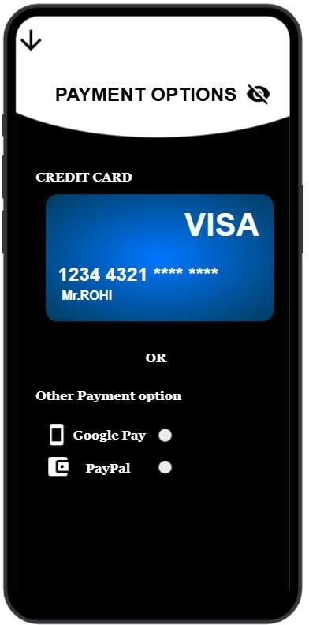

Purpose: Select payment method. Familiar Icons

- Credit card layout
- Radio selection buttons Unfamiliar Icons
- Eye-slash icon near title
  - Custom privacy/security indicator.
- Down arrow at top instead of back arrow
  - Used for navigation but uncommon.

Screen 6: Payment Successful

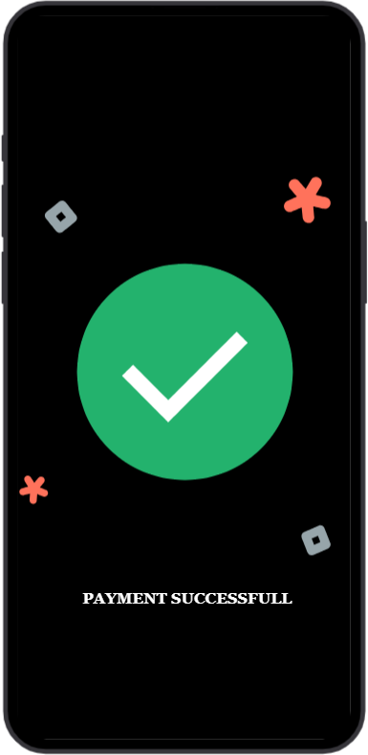

Screen 7: NOTIFICATION PAGE:

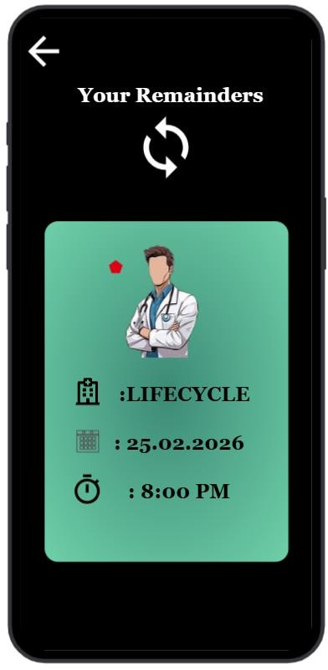

Purpose: Shows booked appointment reminder.
Familiar Icons
- Calendar icon
- Timer icon
- Back arrow Unfamiliar Icons
- Circular sync symbol at top
  - Custom refresh/reminder visual.
  - Meaning unclear initially.

Red pentagon marker
  - Custom highlight indicator.

PROTOTYPE LINK:
https://pr.to/QI7BEH/

